**Project brief Overview:**

I have built a multiservice application "UserDataApp", where there will be three services -

1. **frontend:**

This is a Golang based web application, which will have two pages to add user and to get user details. This will communicate to backend application to add user data and get data back from it.

It contains directories – config (environment files) and src (frontend codebase written in golang),

files – Dockerfile and .dockerignore.

1. **backend:**

This is a Golang based web application, which will save the data, provided through webapi, into Database. User will be able to view that data stored in DB through another webapi.

It contains directories – config (environment files) and src (frontend codebase written in golang)

files – Dockerfile and .dockerignore

1. **database:**

This is MSSQL database. In this, we have 'USERDATA' database and a table named "USERINFO". Data will be stored in this table through backend.

It contains directories – scripts (executed at the time of image creation. It creates database and table in mssqldb), file – Dockerfile.

1. **Compose files:**

There is one single compose file (docker-compose.yml) to define and run the multi-service application.

docker compose files to implement environment variable management to handle different environments (development, testing, production):

We have a base compose file (docker-compose-base.yml) and environment specific compose files as below:

1. **Development Environment:** docker-compose-dev.yml
2. **Test Environment:** docker-compose-test.yml
3. **Production Environment:** docker-compose-prod.yml

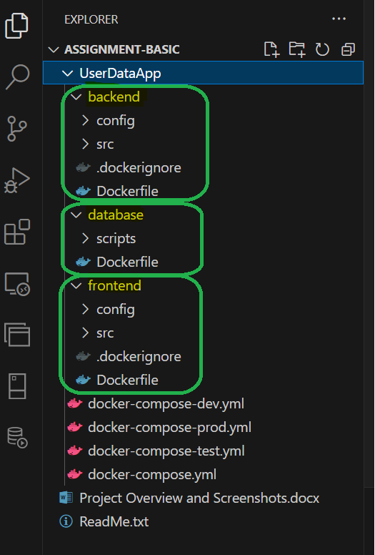

**Screenshots of setup:**

**Networks created:**

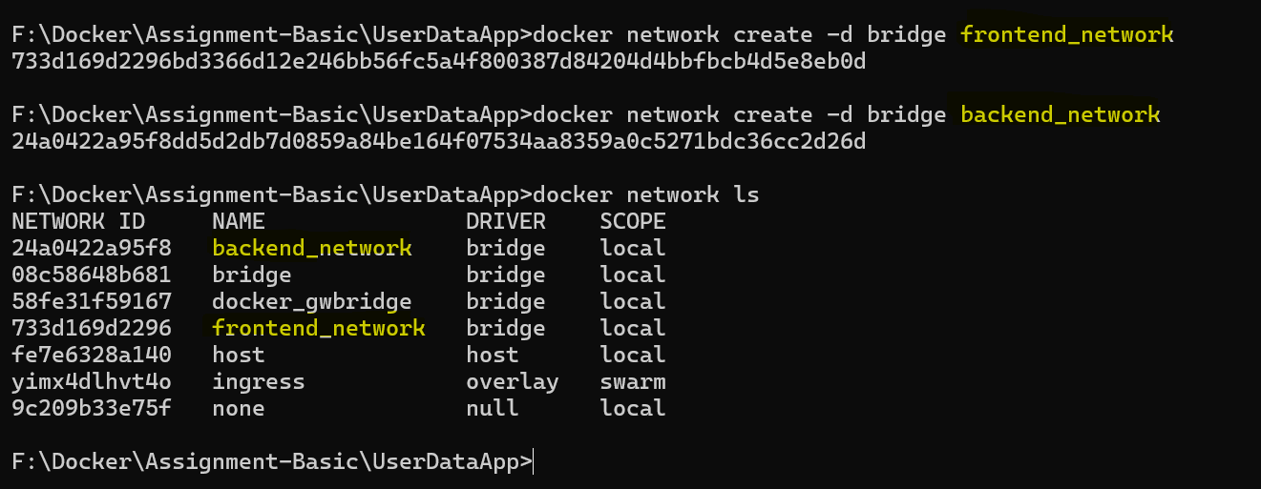

**Images Created:**

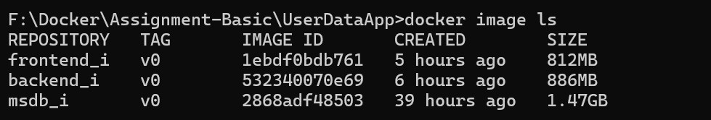

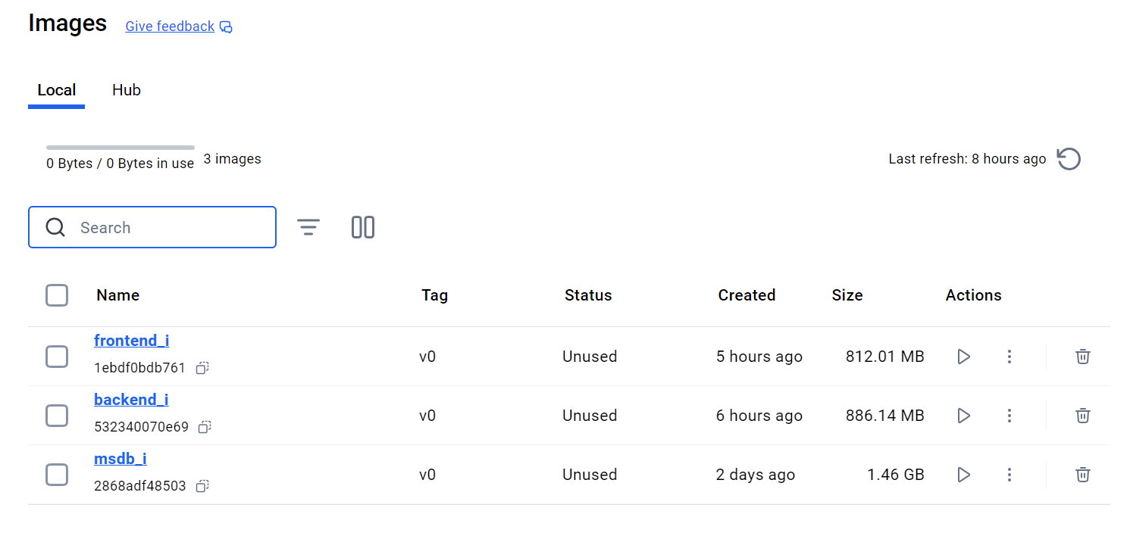

**Containers Created:**



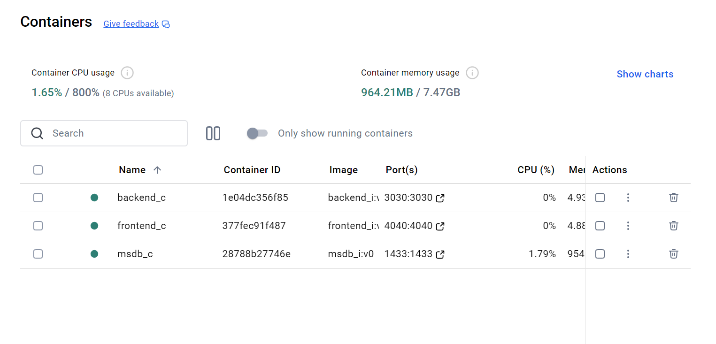

**Screenshots of running application:**

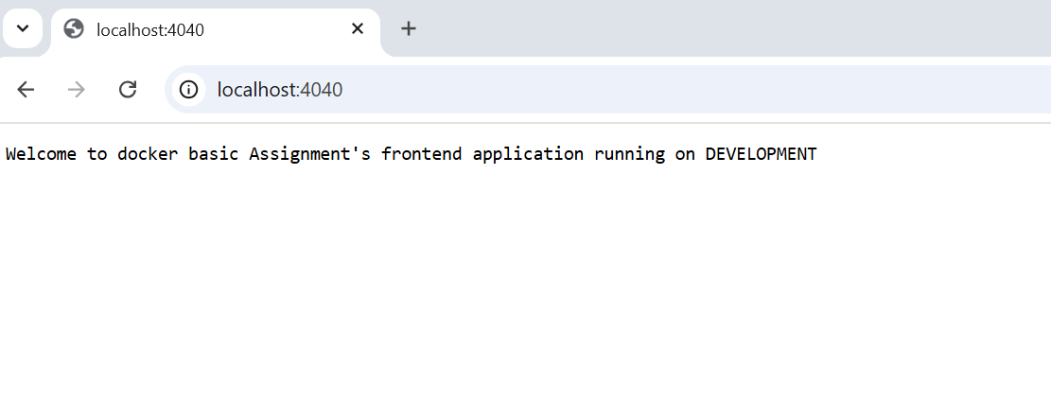

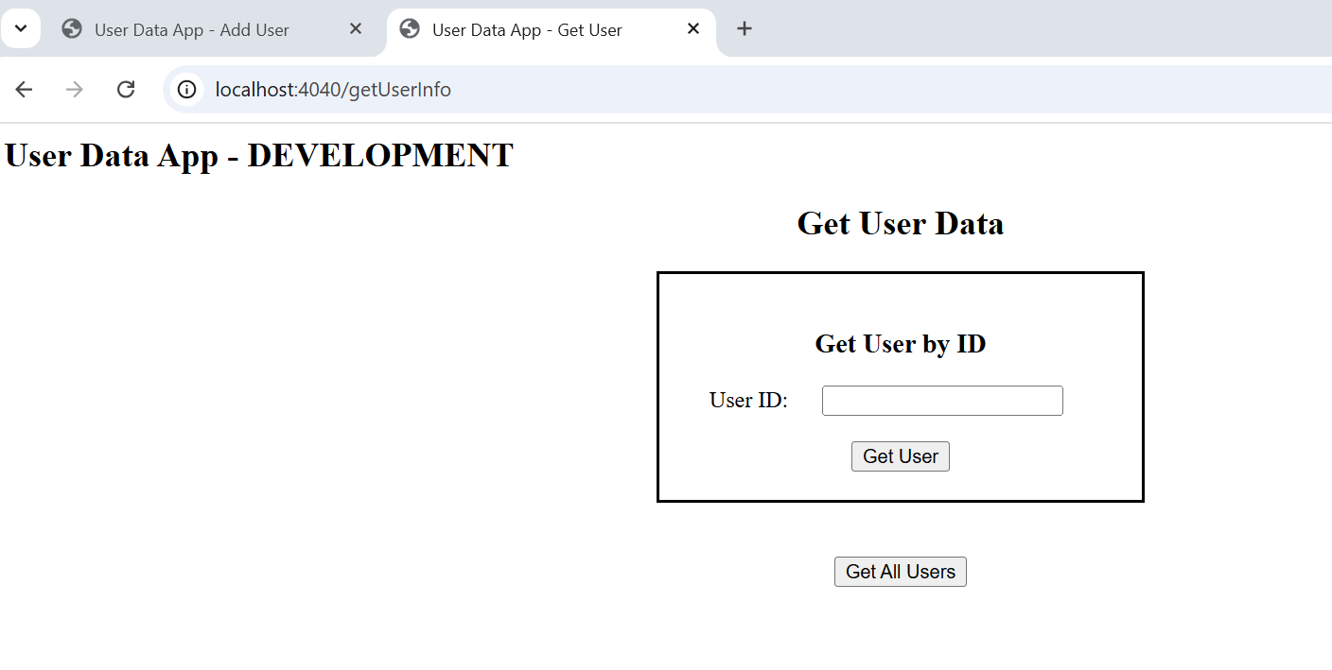

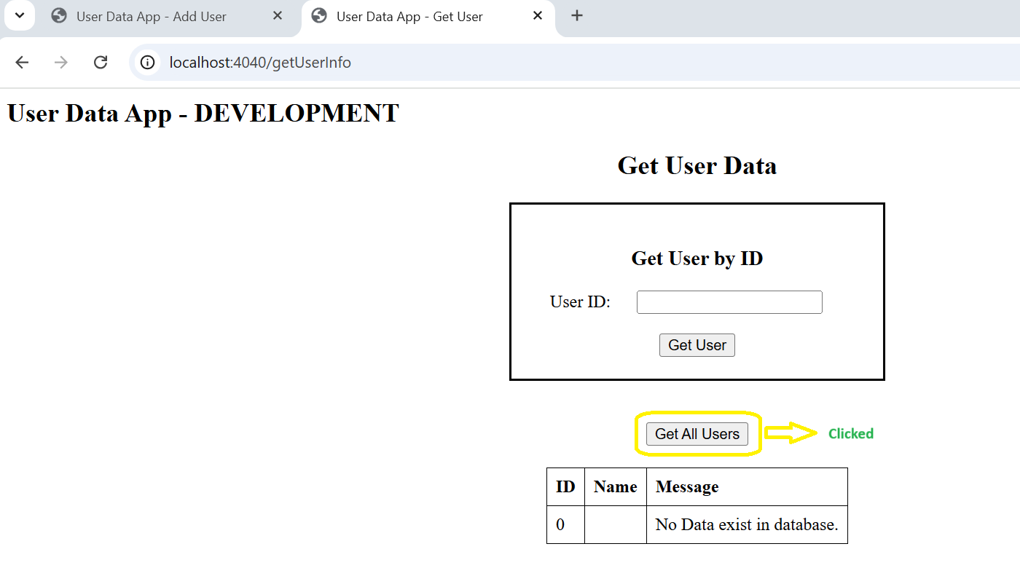

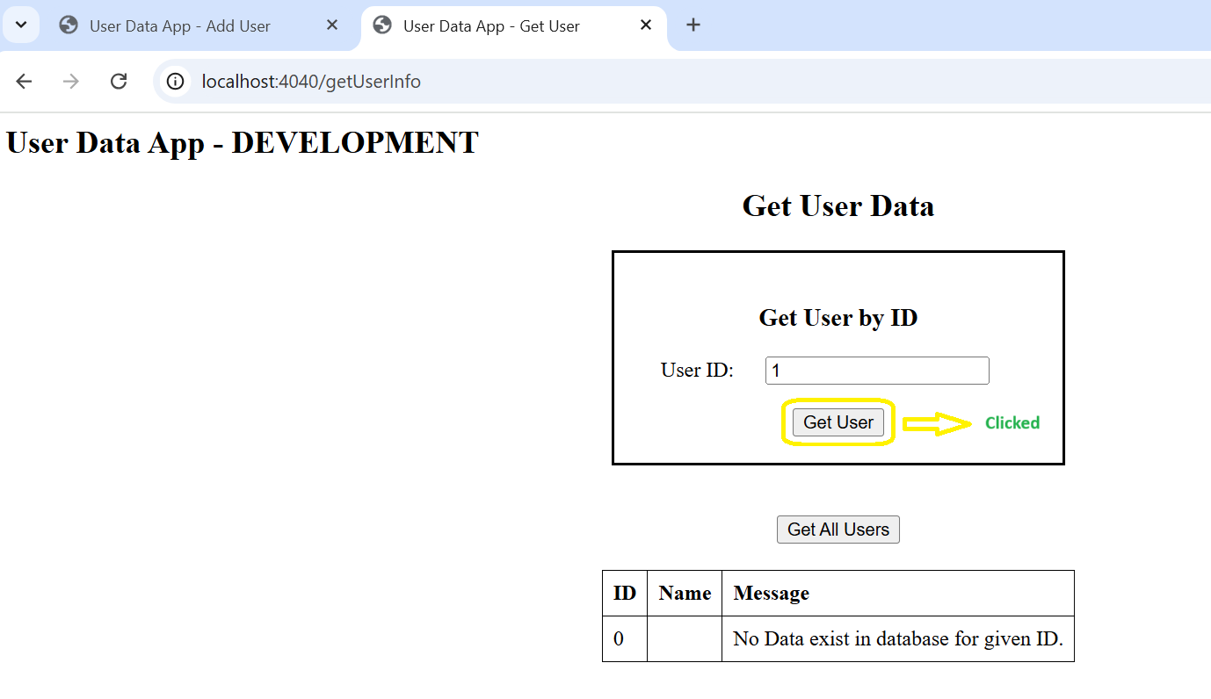

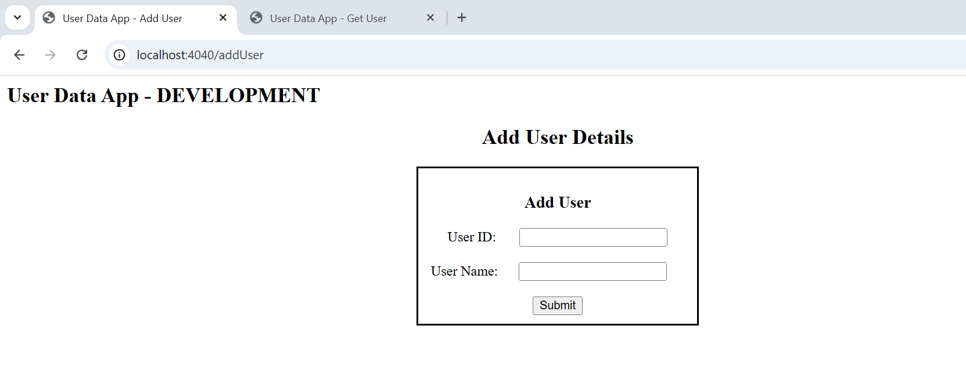

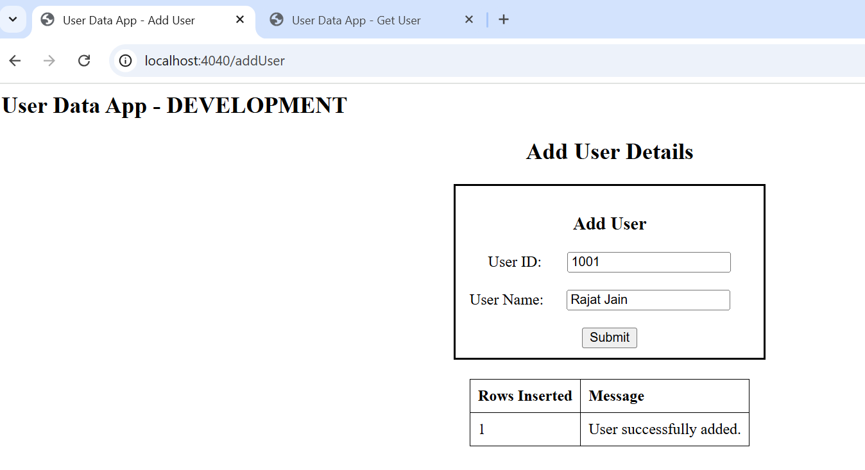

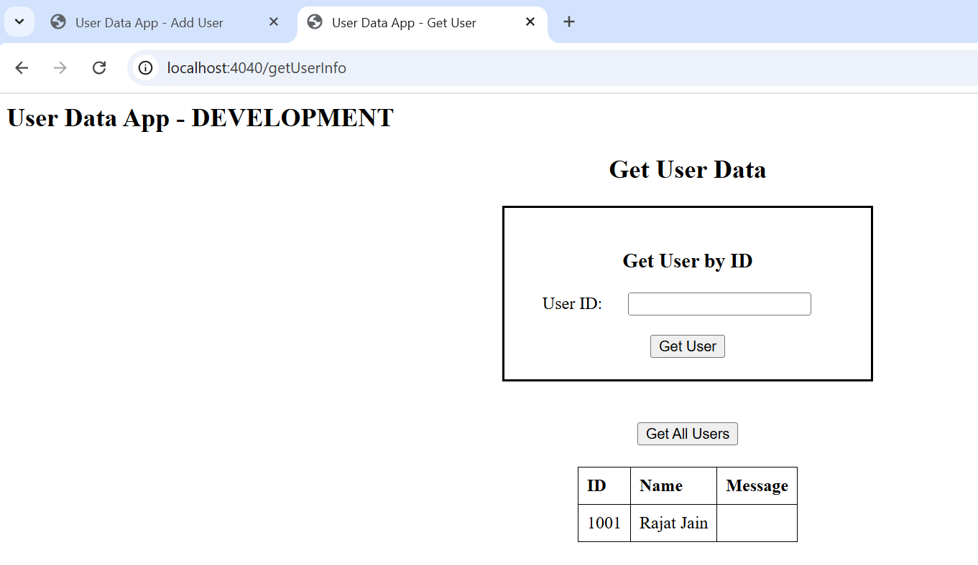

**Docker compose:**

**Images created:**

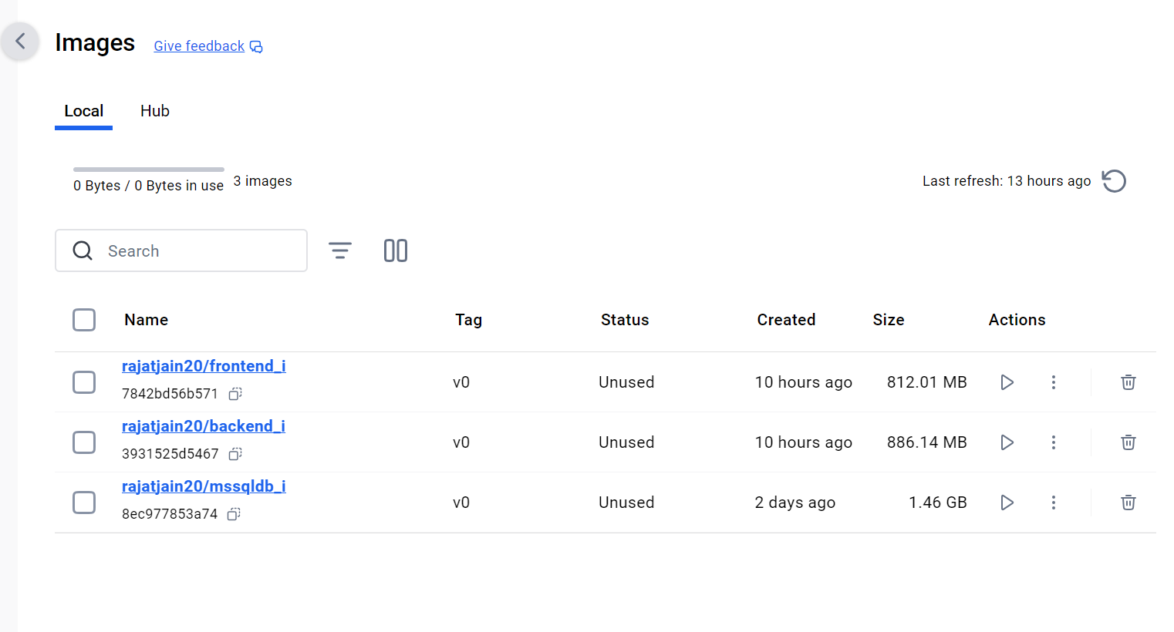

**Containers Created:**

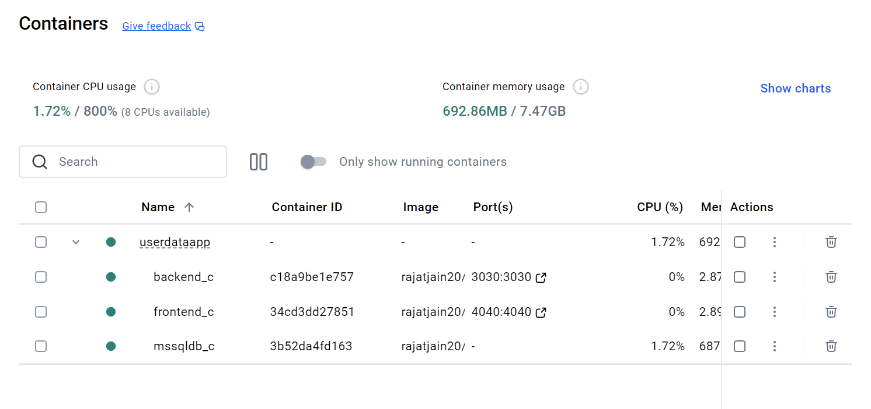

**Screenshots of running application after docker compose:**

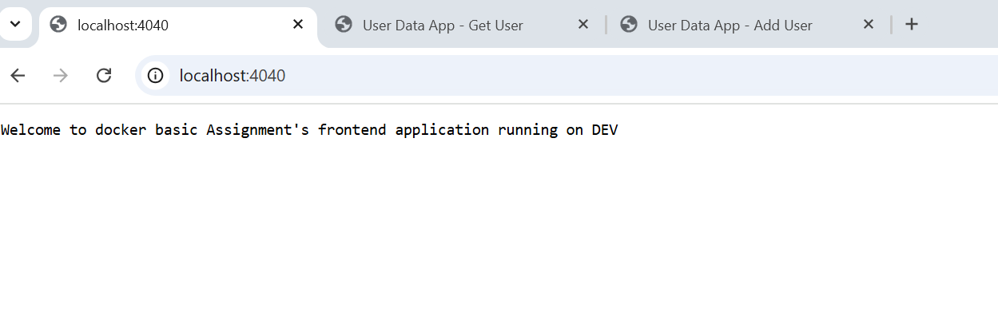

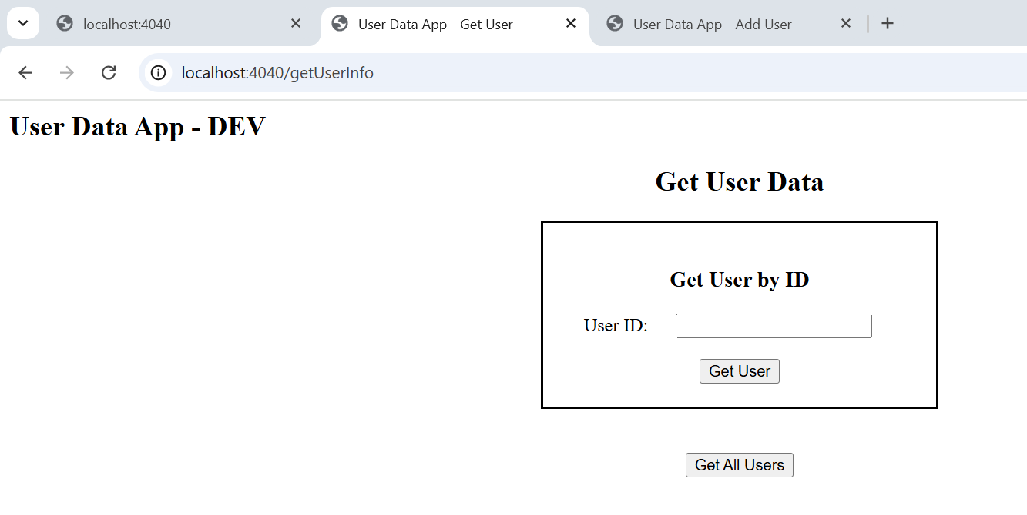

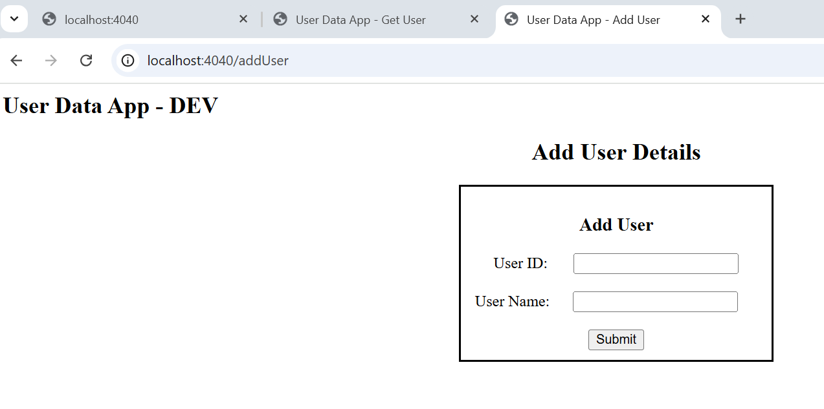

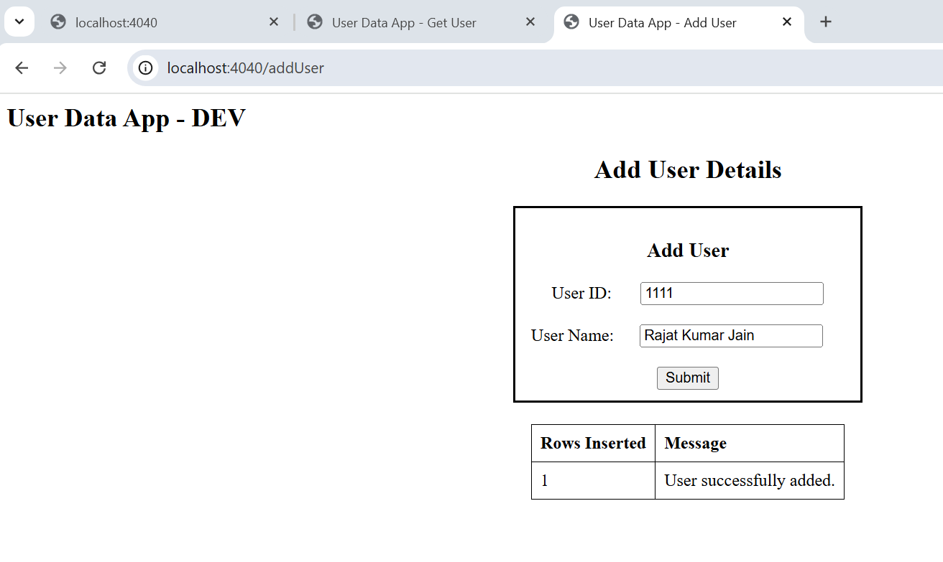

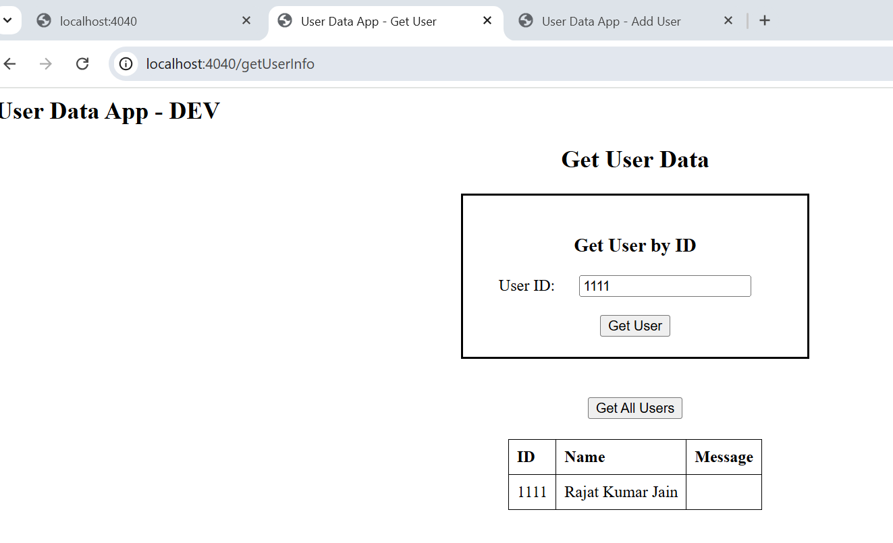

**Implement environment variable management in your Docker Compose file to handle different environments (development, testing, production):**

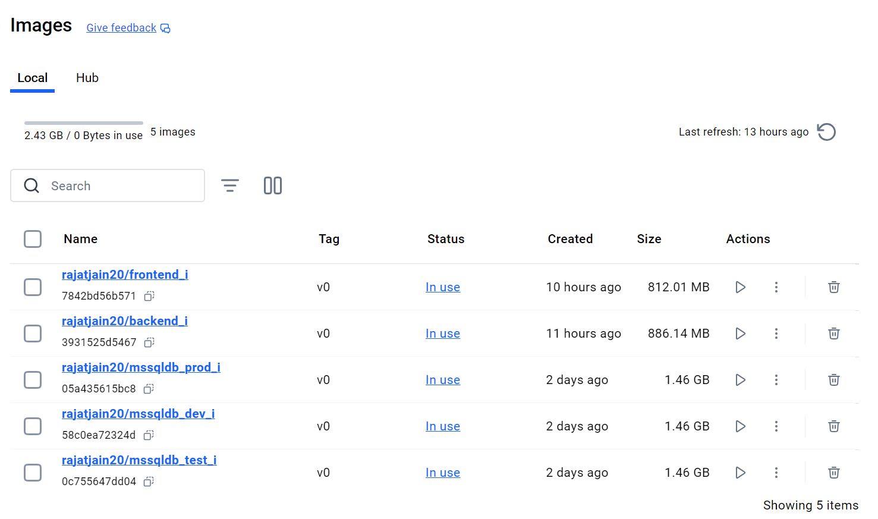

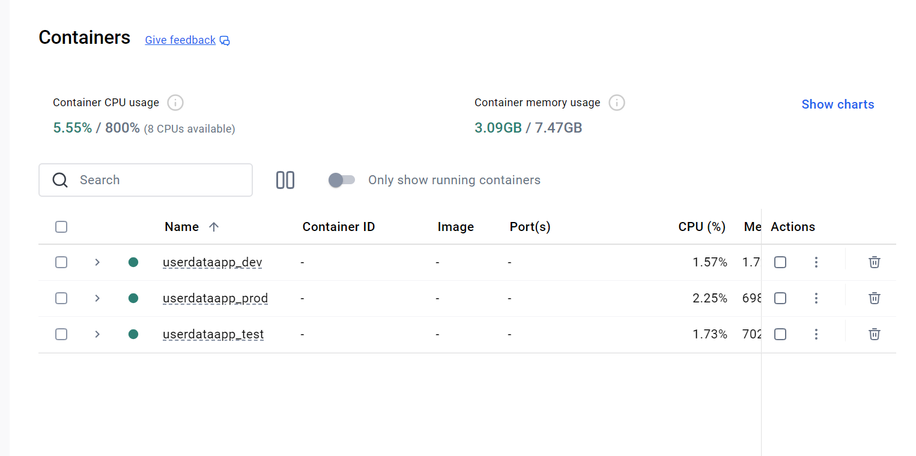

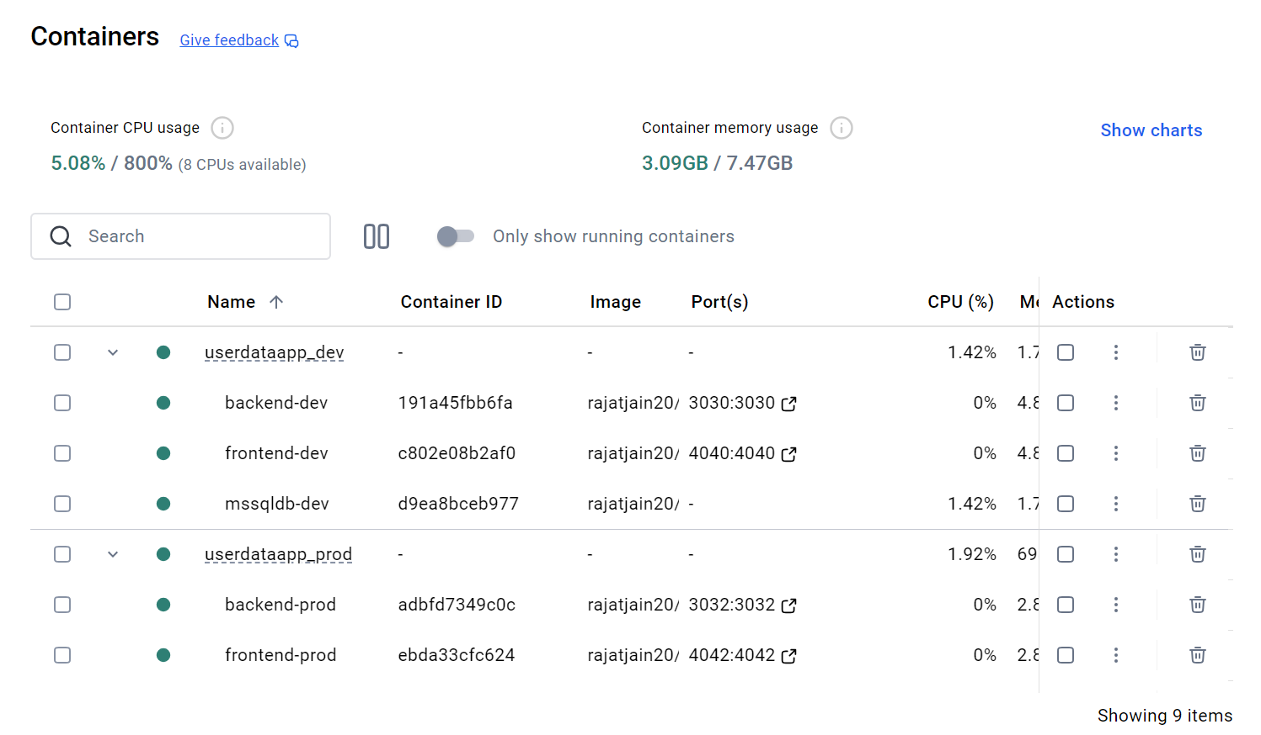

**Snapshots of running applications:**

**Development Environment -**

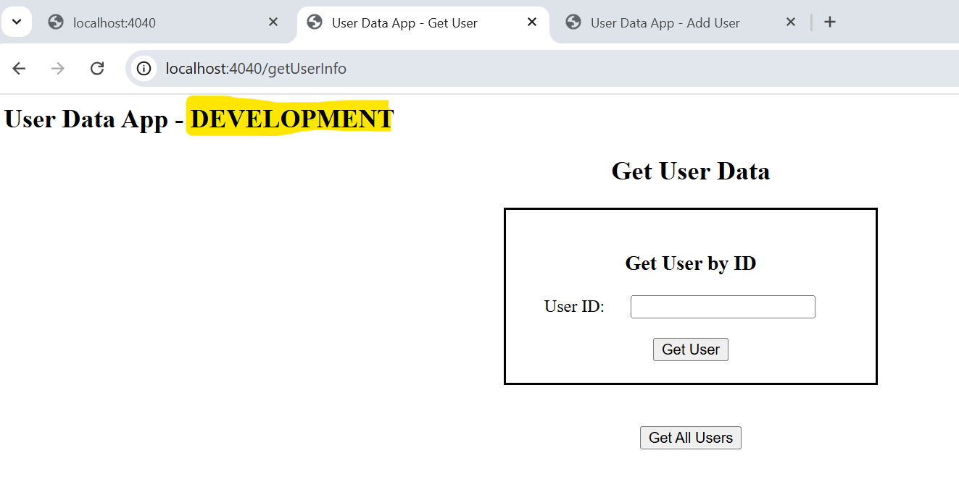

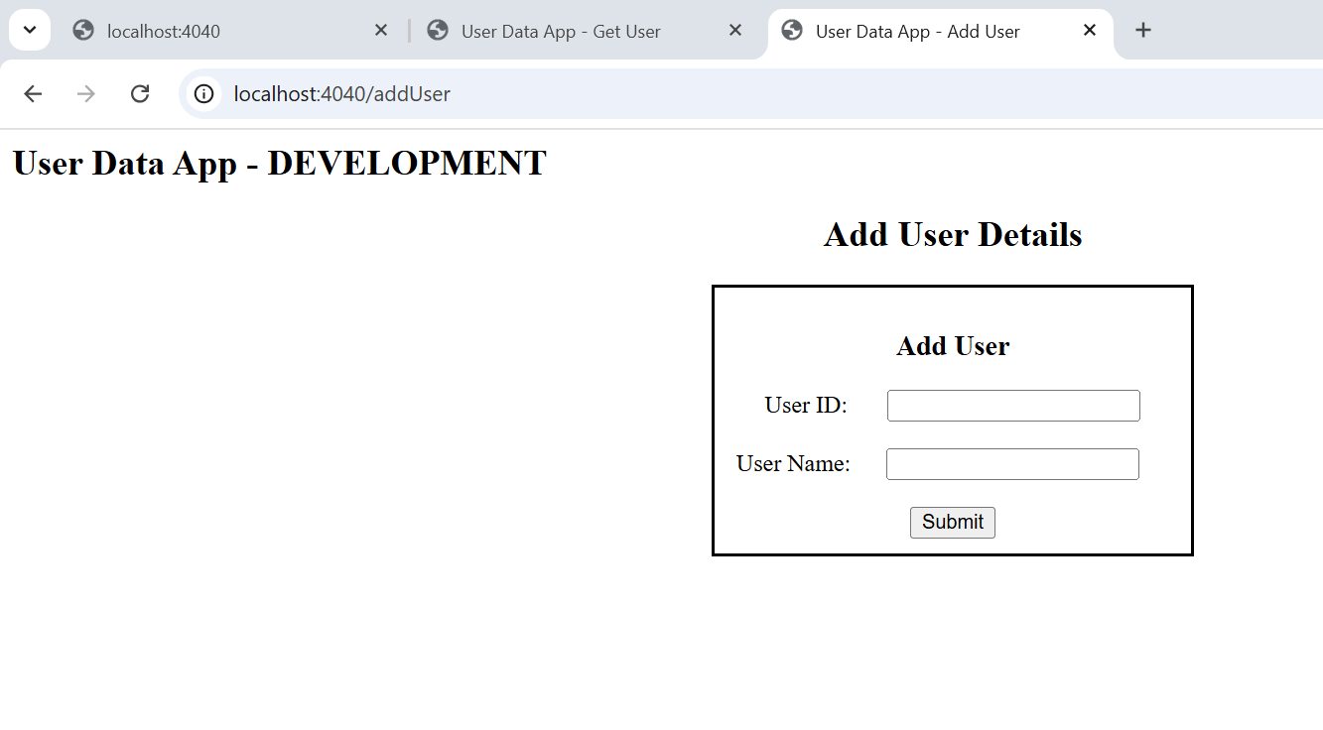

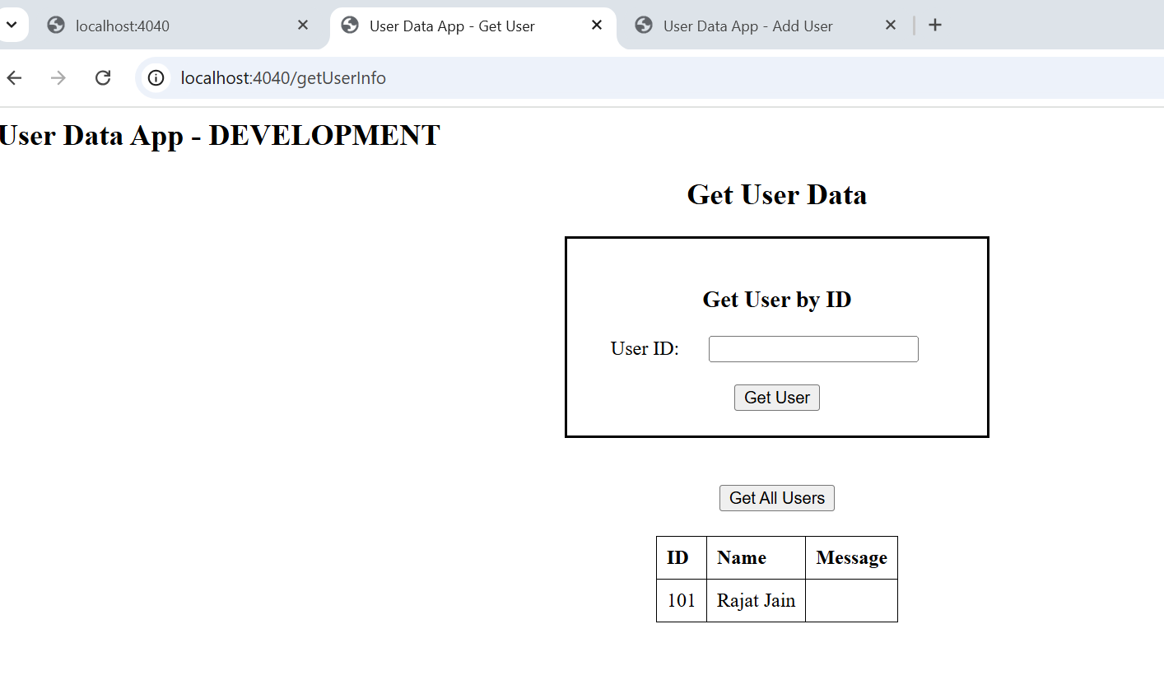

**Testing Environment -**

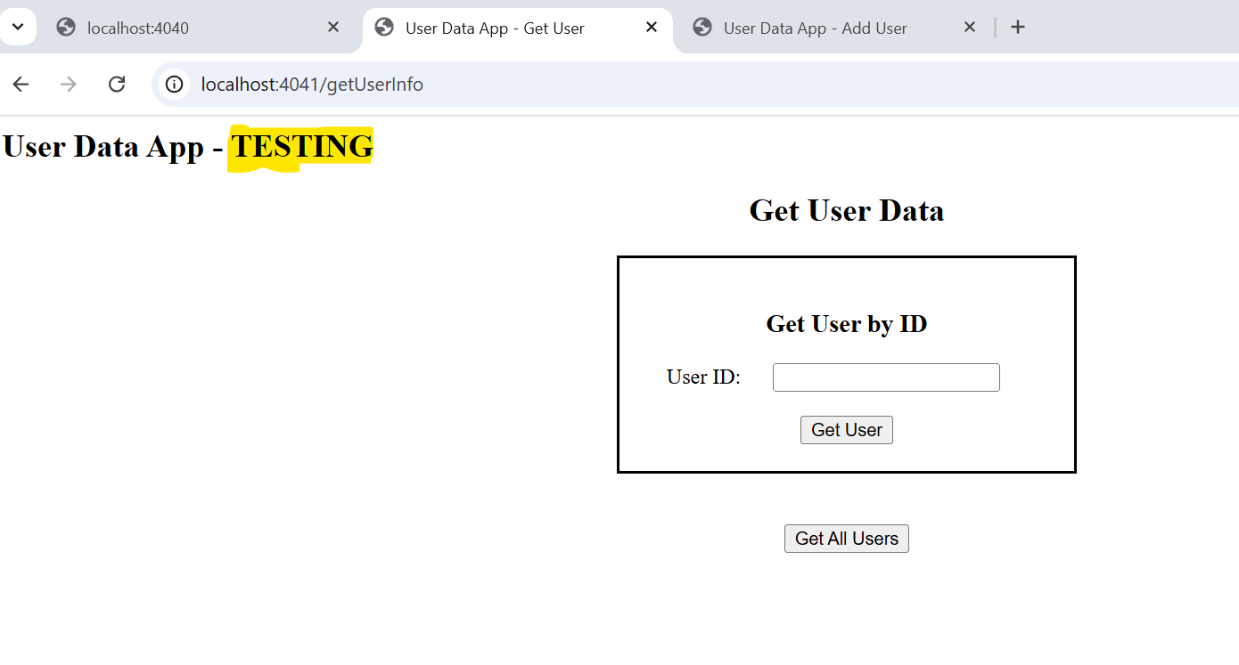

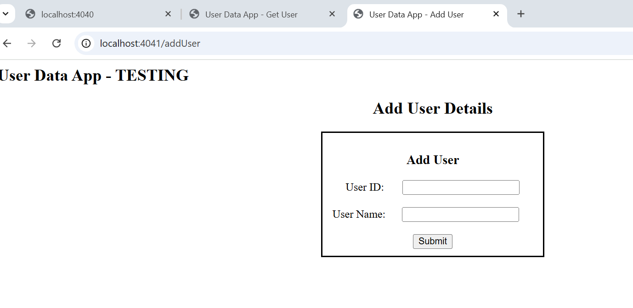

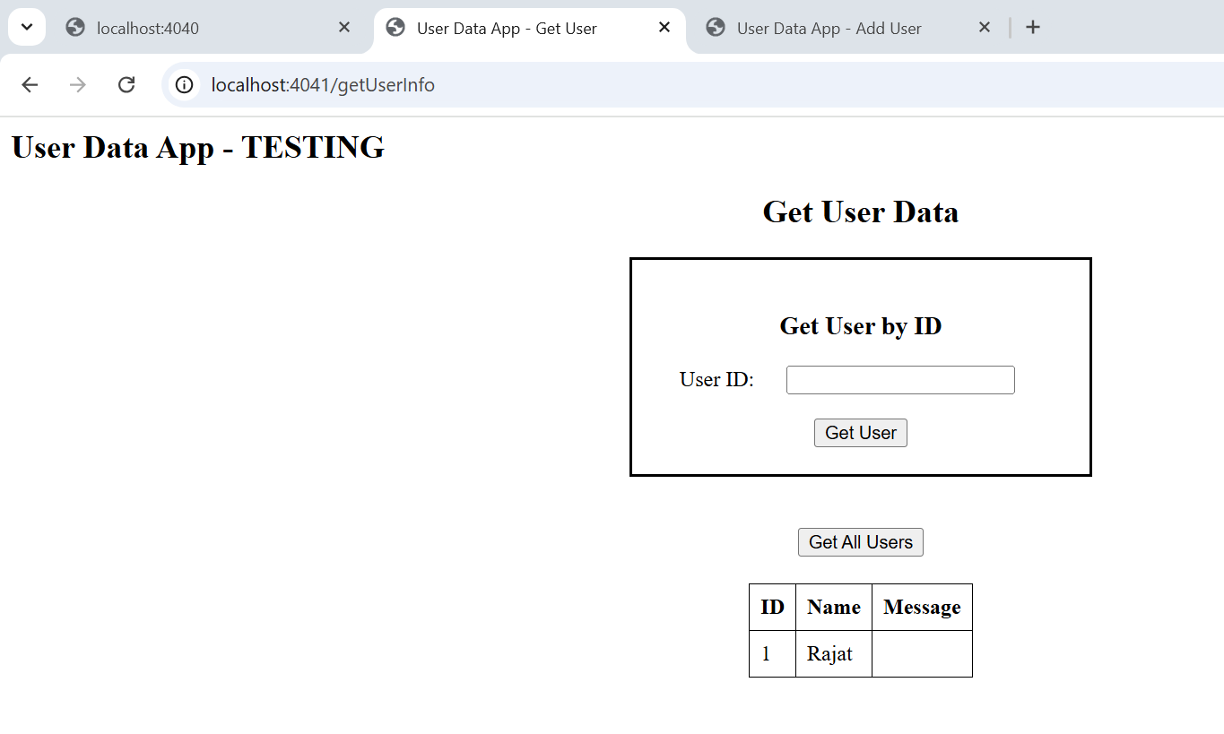

**Production Environment:**

